# Switch in C++

Practice 01:

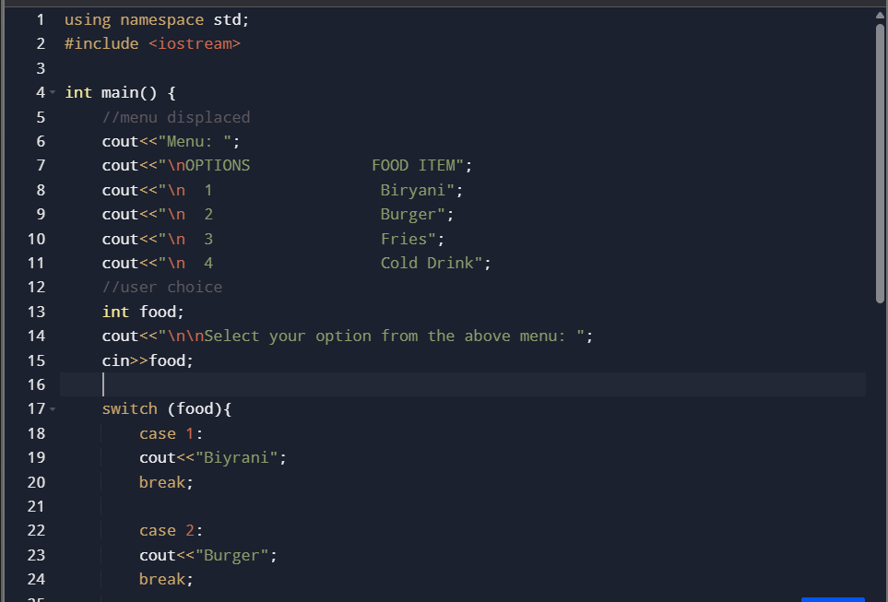

Practice 02

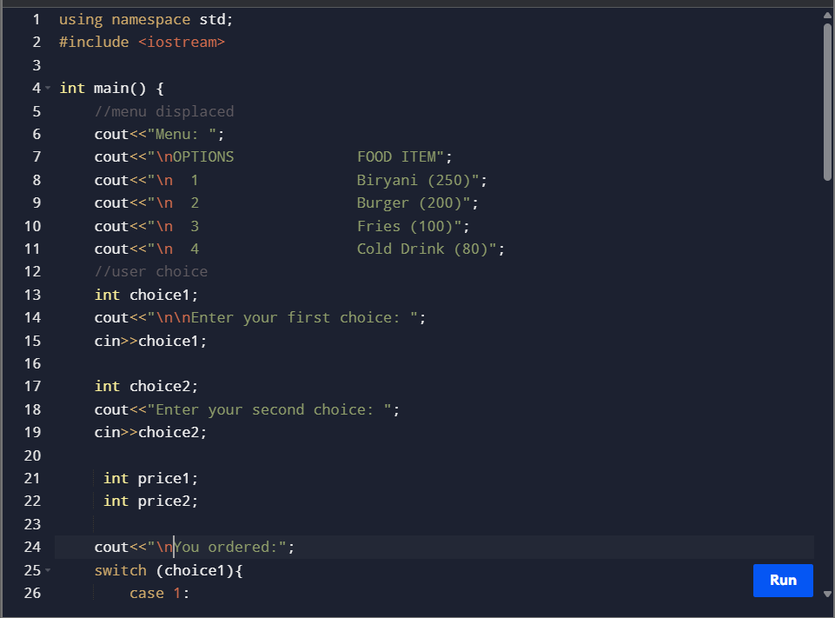

Practice 03

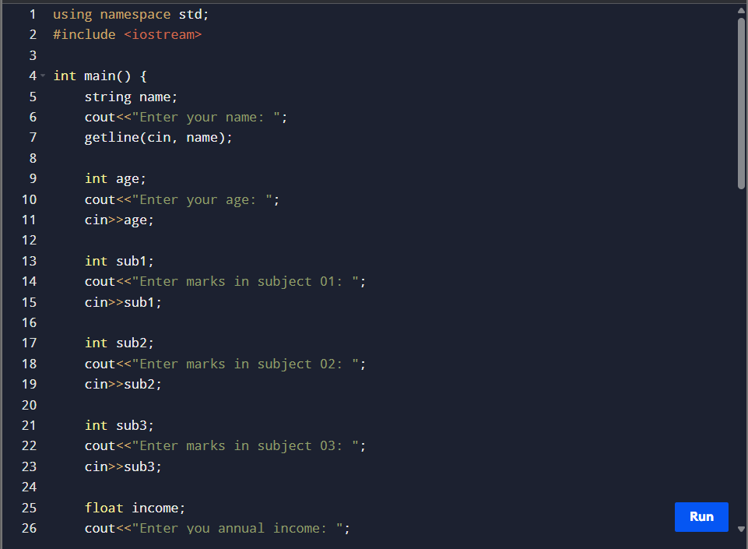

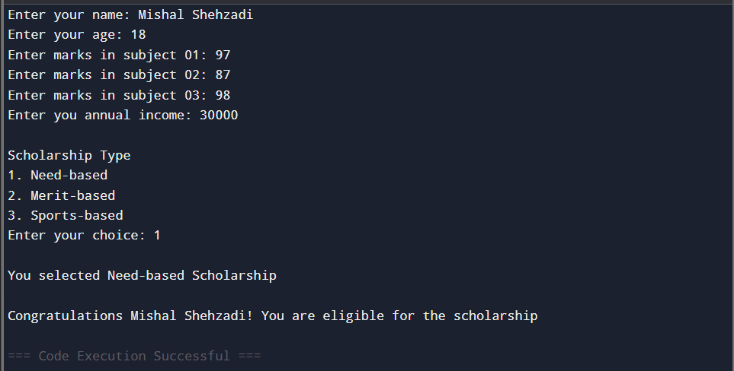

Practice 04:

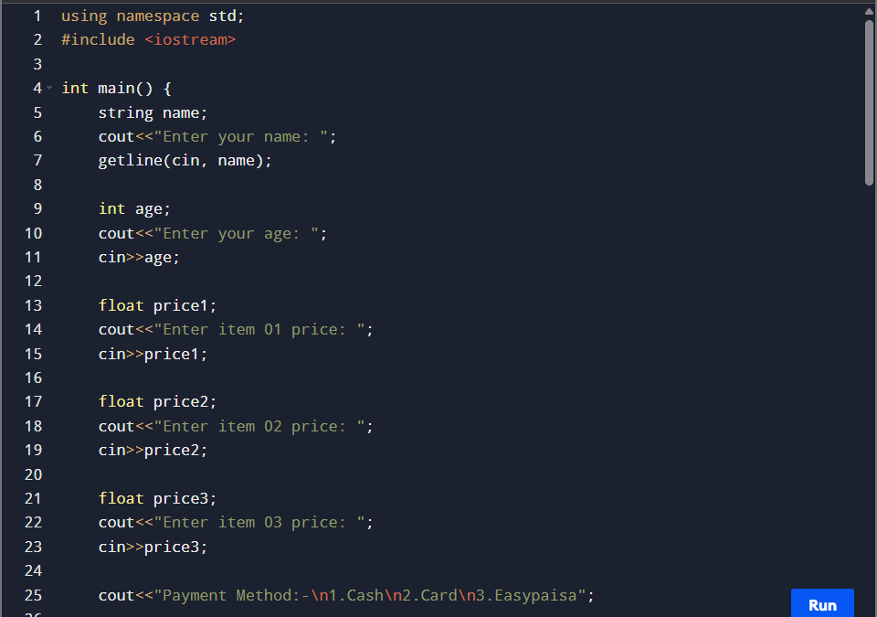

Practice 05:



